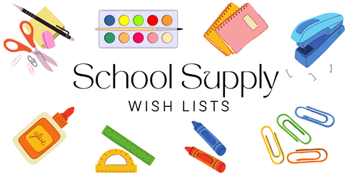

**KINDERGARTEN – DUAL LANGUAGE ONLY**

**24/25**

2 MEAD PRIMARY COMPOSITION BOOKS – ANY COLOR

1 PLASTIC PENCIL BOX

6 BOXES OF CRAYOLA CRAYONS (24ct)

1 BOX OF CRAYOLA MARKERS (FAT)

10 ELMER GLUE STICKES (FAT)

1 BOX OF CRAYOLA WASHABLE WATERCOLORS – 8ct (PAINT)

3 PERMANENT SHARPIE MARKERS (BLACK)

1 BOX OF MAGIC ERASERS (2 PACK)

2 BLACK EXPO DRY ERASE FINE TIP MARKERS

2 MULTI-COLOR EXPO DRY ERASE CHISEL TIP MARKERS

48 #2 DIXON TICONDEROGA PENCILS (SHARPENED)

2 PAIRS FISKAR 5” SCISSORS BLUNT TIP

3 PLASTIC POCKET FOLDERS WITH PRONGS (1 RED, 1 GREEN & 1 BLUE)

1 PAIR OVER THE HEAD HEADPHONES (NO EARBUDS)

3 LANYARDS WITH ID HOLDER

2 REAMS OF COPY PAPER

2 WHITE 3 RING BINDERS (2 INCH)

1 BOX TISSUES

1 PACKAGE BABY WIPES

1 BOX CLOROX WIPES

1 BOX QUART SIZE ZIPLOCK BAGS

1 BOX GALLON SIZE ZIPLOCK BAGS

1 25 PACK SHEET PROTECTORS FOR 3 RING BINDER

1 PINK ERASER